1. Serverless Functions

1. Database

A screenshot from the Azure portal showing the database & collections

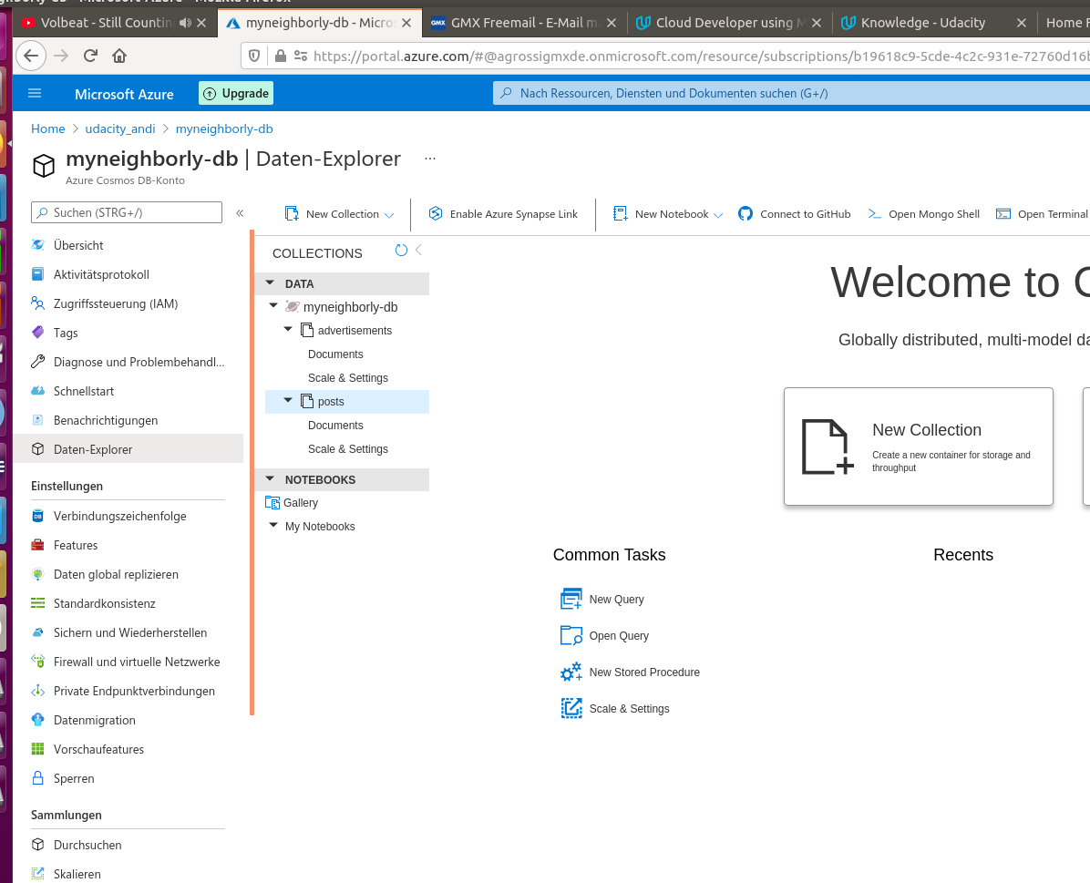

2. A screenshot from the terminal giving confirmation that the two pieces of sample data for advertisements (5 documents) and posts (4 documents) were imported correctly, or include this data in the live website.

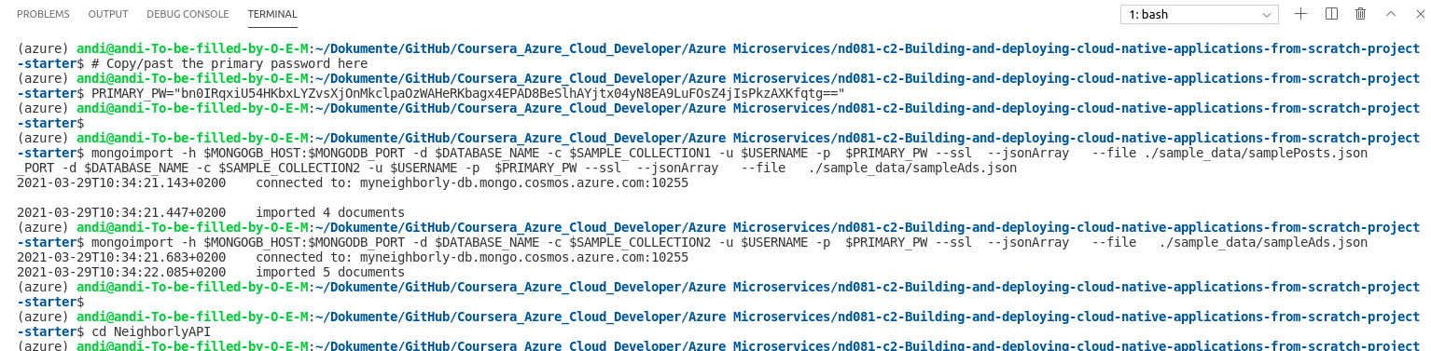

2. Triggers in Azure

A screenshot, including URL, from the Azure portal where it is shown what endpoints are live.

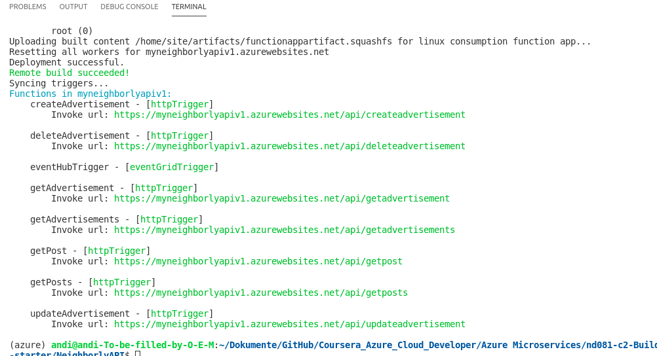

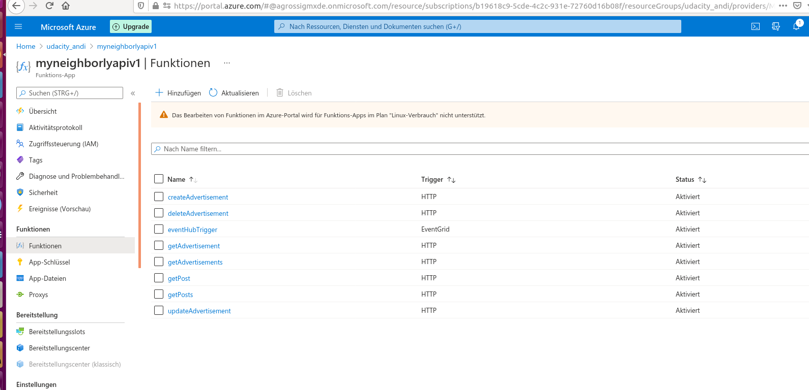

3. Triggers Connect to Database

A screenshot, including URL, of at least the data returned from querying the getAdvertisements endpoint; other endpoints will be checked for reasonableness within the related code files.

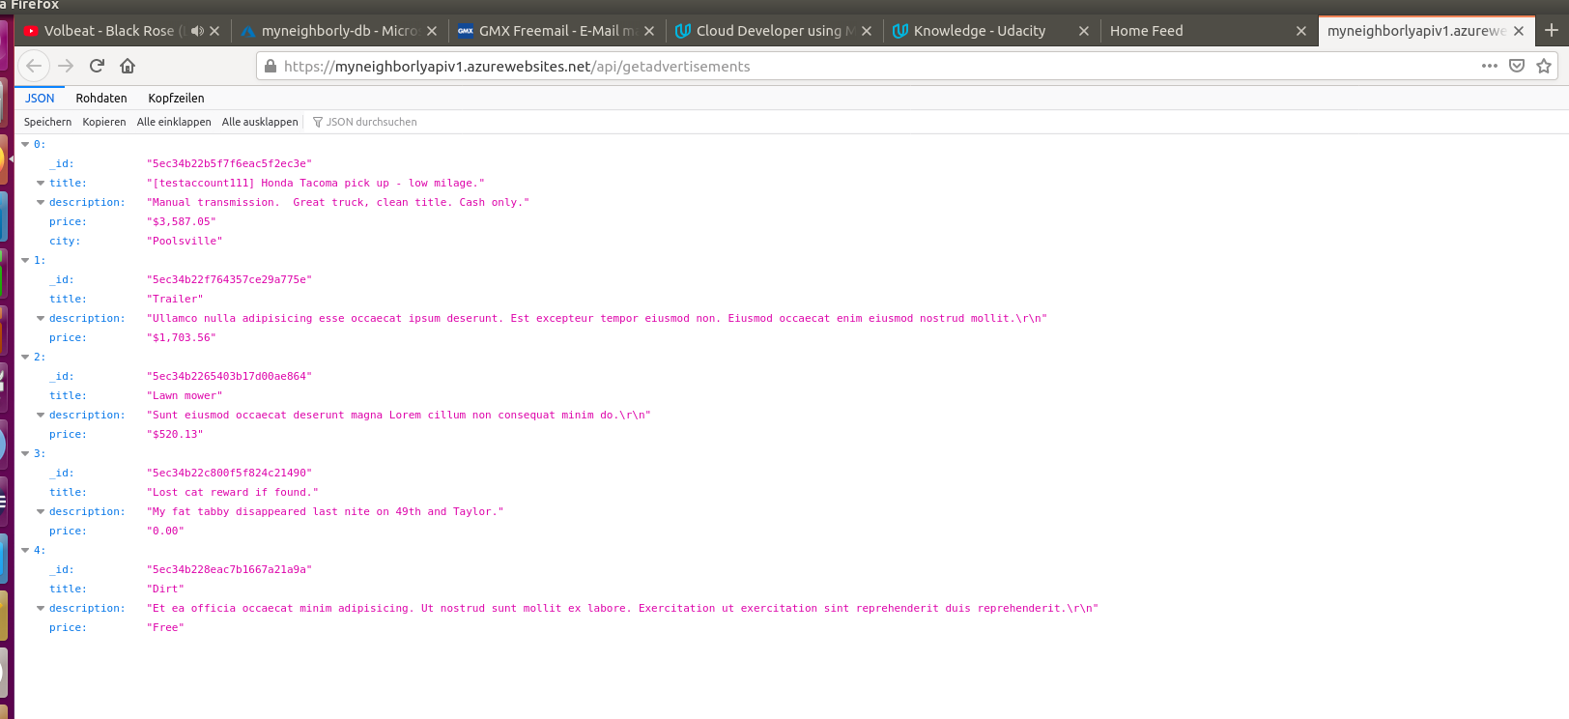

4. Flask Front End

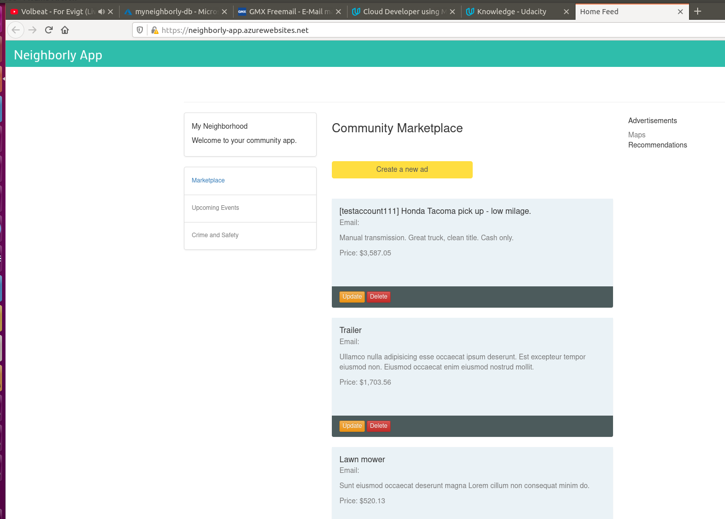

2. Logic Apps & Event Hubs

1.Logic App: here is the screenshot from my logic app

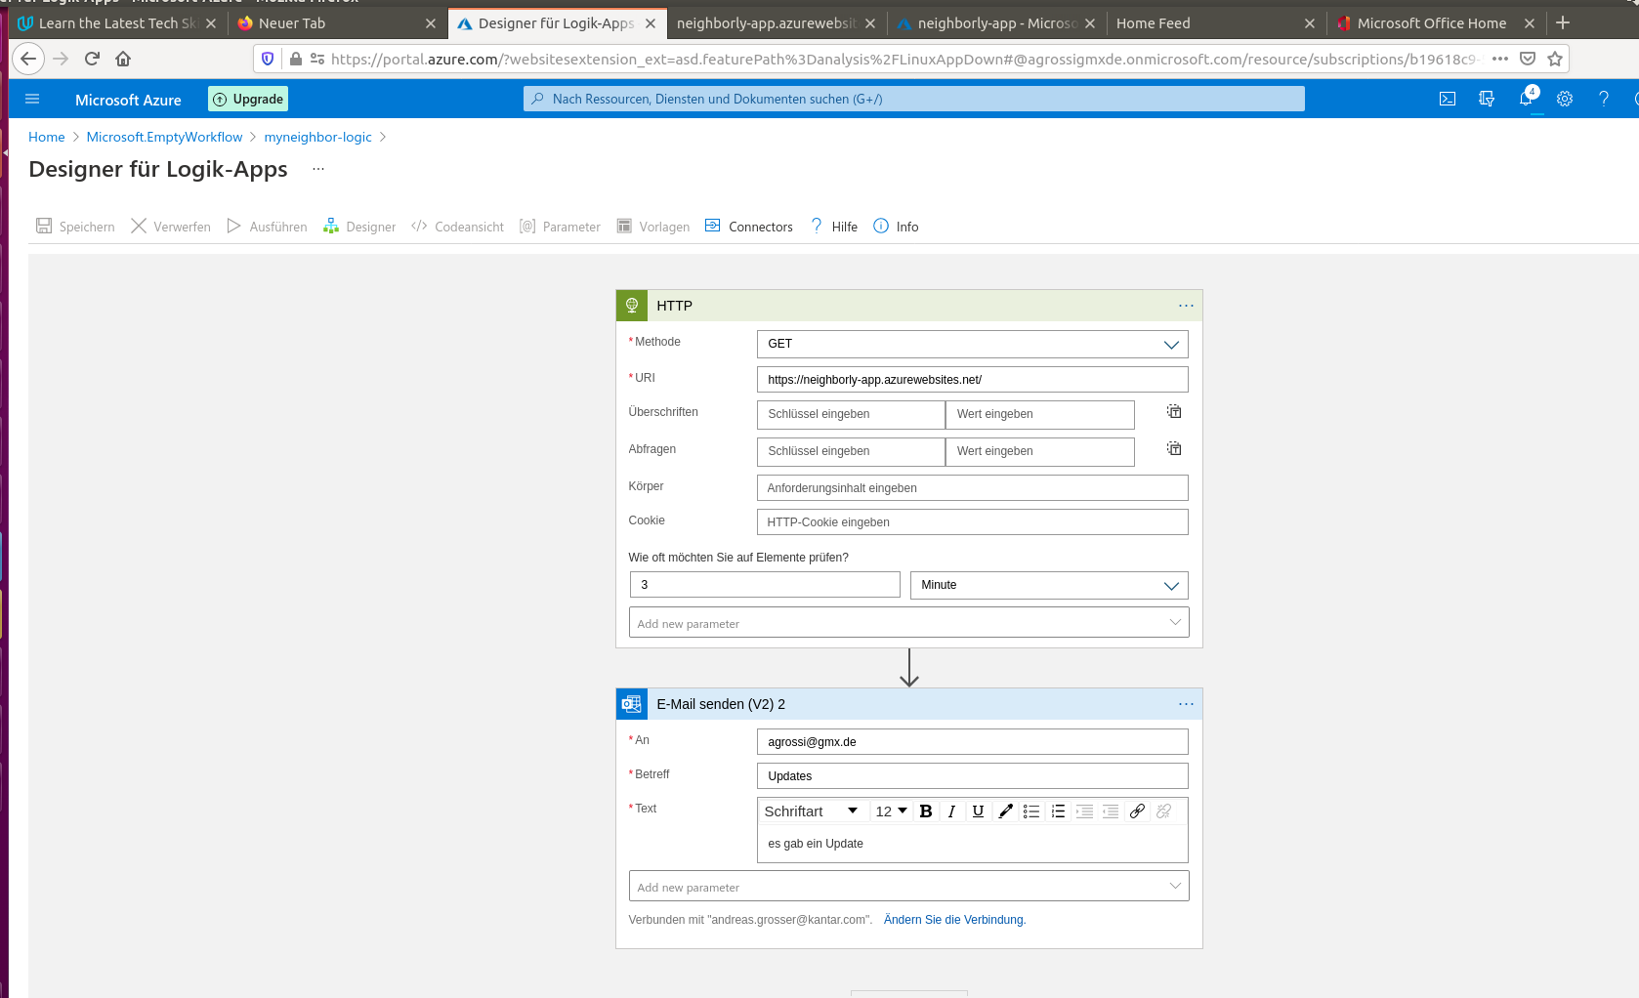

2.Event Hub

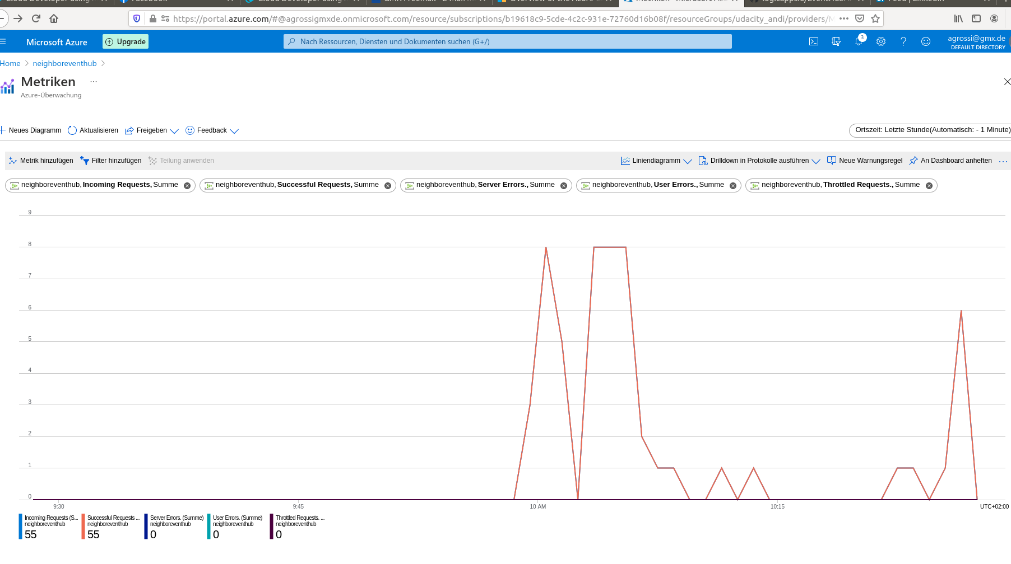

3. Deploying Your Application

1. App Service Deployment - The live url from Azure App Service (which should be accessible to all users on the World Wide Web), or a screenshot should be provided, including the URL, of the previously live site.



2. Dockerfile - A screenshot of the Dockerfile from Azure Container Registry as evidence.

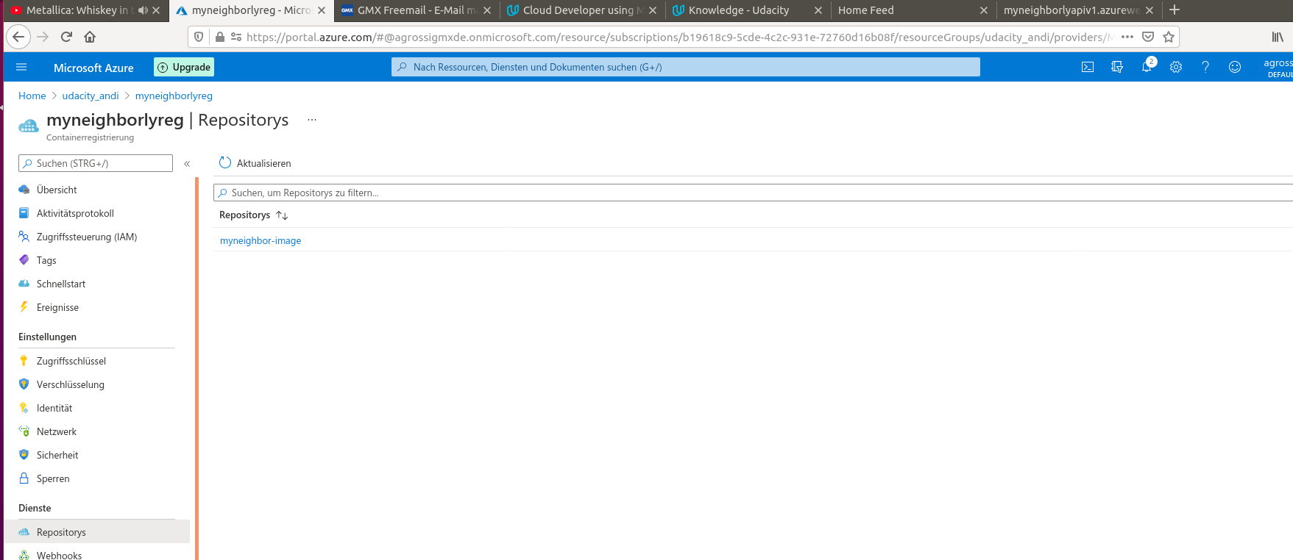

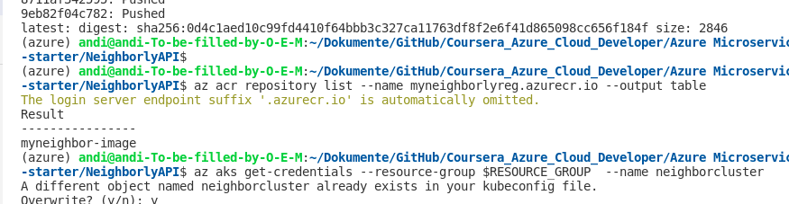

3. Kubernetes - A screenshot of confirmation from the terminal, or from within Azure, as evidence.

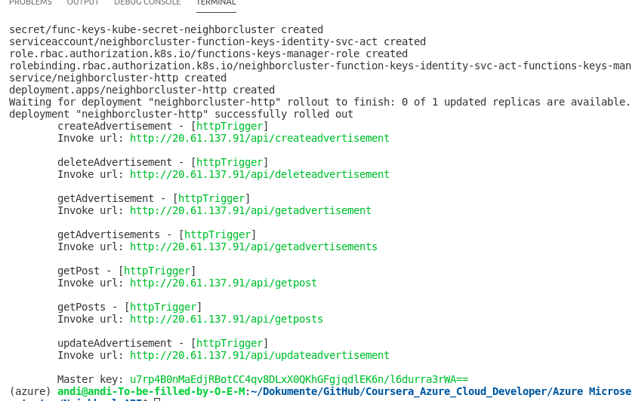

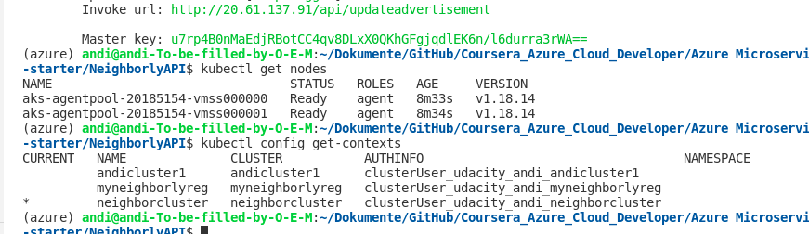

In general all created elements in Azure:

